Vilnius, LITUANIA
July 5th 2023

PRESS RELEASE
Ref 20230705-01

HighWind Emergency Calls [FRANCE] and GAGDPR [GREECE] are proud to announce their common award to the European call for tender SecurIT, in the Disaster Resilience category with their project “AI DISASTER EMERGENCY COMMUNICATIONS” also known as “Disaster Mode”.
Fully funded by the EU and under the supervision of SAFE Cluster, the project will aim to prototype a disaster’s communication web-interface for the population, known as “Disaster Mode”, remotely activated by the reception of an alert text message (EU-ALERT system), and capable to communicate position, AI-analyzed pictures, and key information to the local authorities & emergency dispatchers.
Designed with the feedbacks of major disasters’ survivors & emergency dispatchers, the project aims to address the typical emergency calls congestion occurring during any disasters (riots, wildfire, landslide, terror attack, etc.) by providing an interface for the population of a given area to report on a map their safety check status and emergency situation for the local authorities.
Using HighWind’s patented pre-diagnostics AI module to assess critical level of each person, GAGDPR will provide the legal GDPR-compliant framework to ensure the respect of the solution for privacy and EU rules.
Once completed, the project will be fully “plug & play”, with no installation required and that can be integrated as a web URL link in any mass text message alert (EU-ALERT, FR-ALERT, NL-ALERT, etc.) in Europe, in accordance with the European Electronic Code of Communications’ standards.
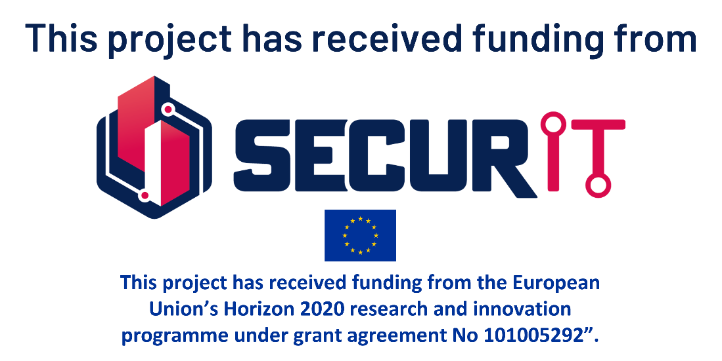
HighWind and GAGDPR are committed to provide the most cutting edge technology, in full compliance with EU regulations, to the populations, emergency services and local authorities in order to fight disasters affecting the populations.

All images and logo are available for the press and free of rights. They can be used at discretion.
For any information, please contact: [FR/EN] Adrien RICCI – Adrien.ricci@highwind-ems.com or [GR/EN] Ioannis GOUMENOPOULOS – g.goumenopoulos@gagdpr.com

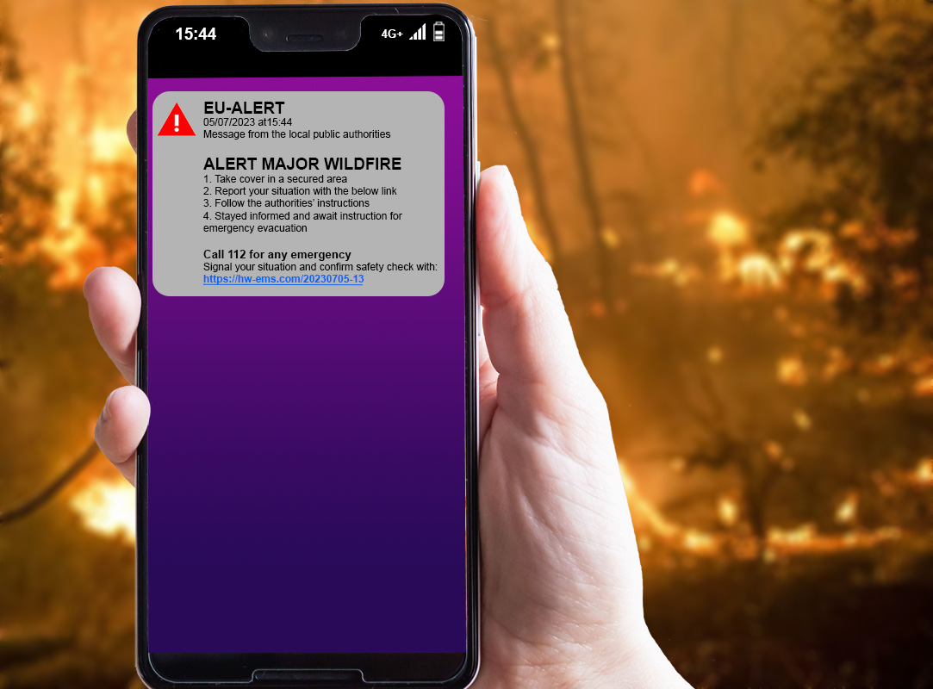
STEP 1 : EU-ALERT text message reception including the solutions’ link (URL). As per the European Electronic Code of Communication, these text messages can be broadcasted to the population within an identified area. This system already exist and requires no modifications.

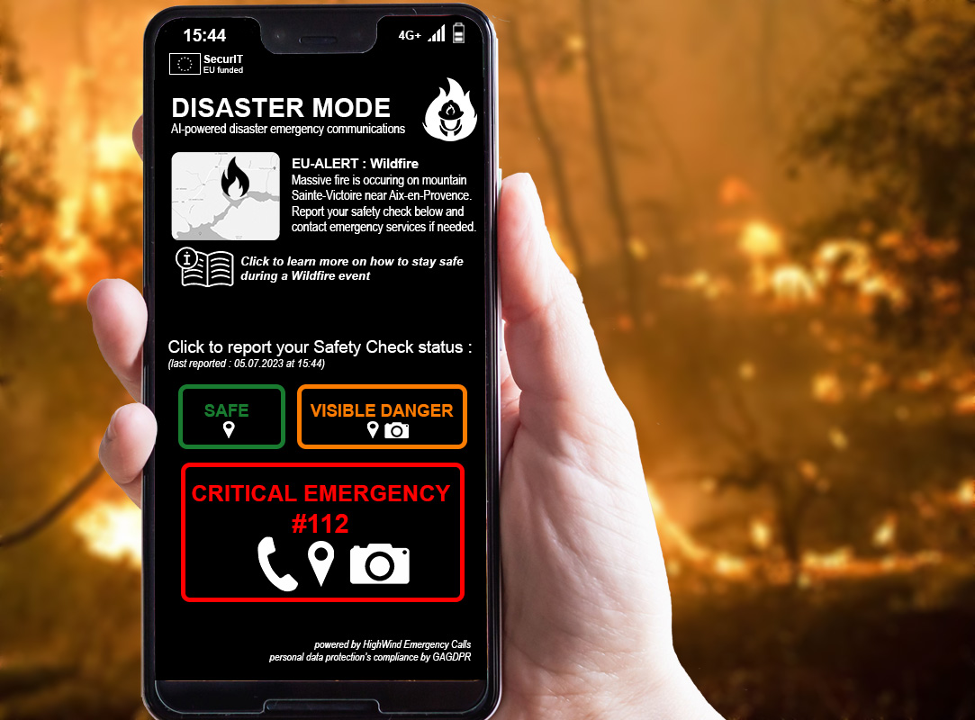
STEP 2 : opening the disaster communication interface for information and to report the situation of each person

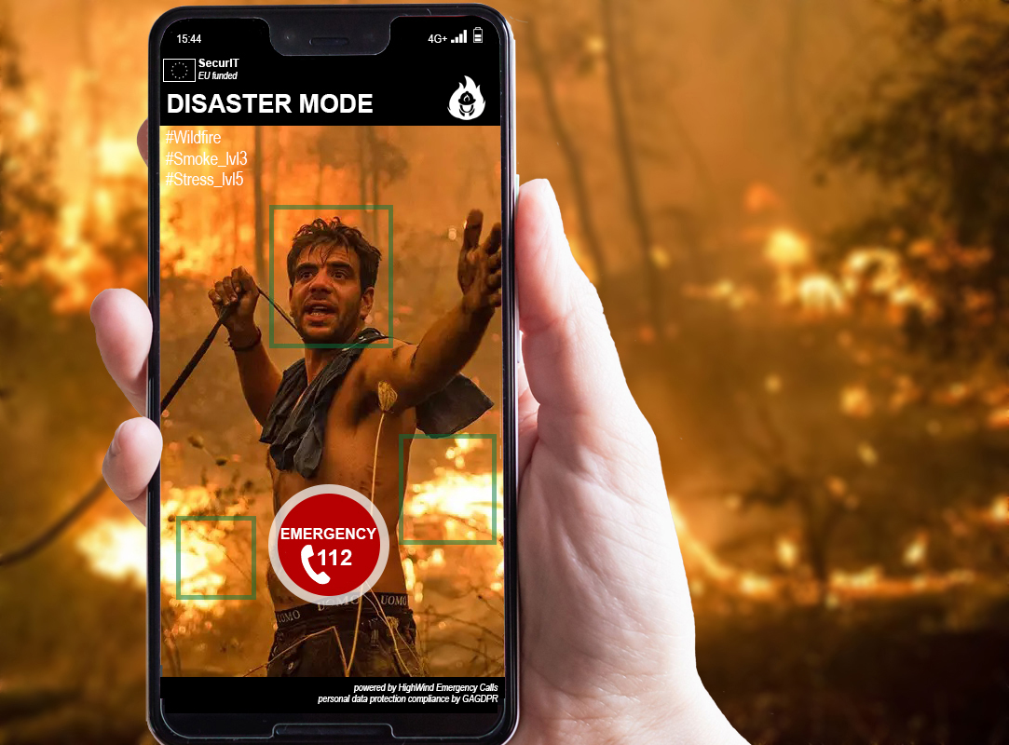
STEP 3 : sending GPS position, pictures analyzed by AI and emergency call if required, to the local authorities and emergency services.

STEP 4 : reception by the authorities & emergency services, through a web page, of every safety status report, as per a color code confirmed by AI diagnostic, on a digital map.

